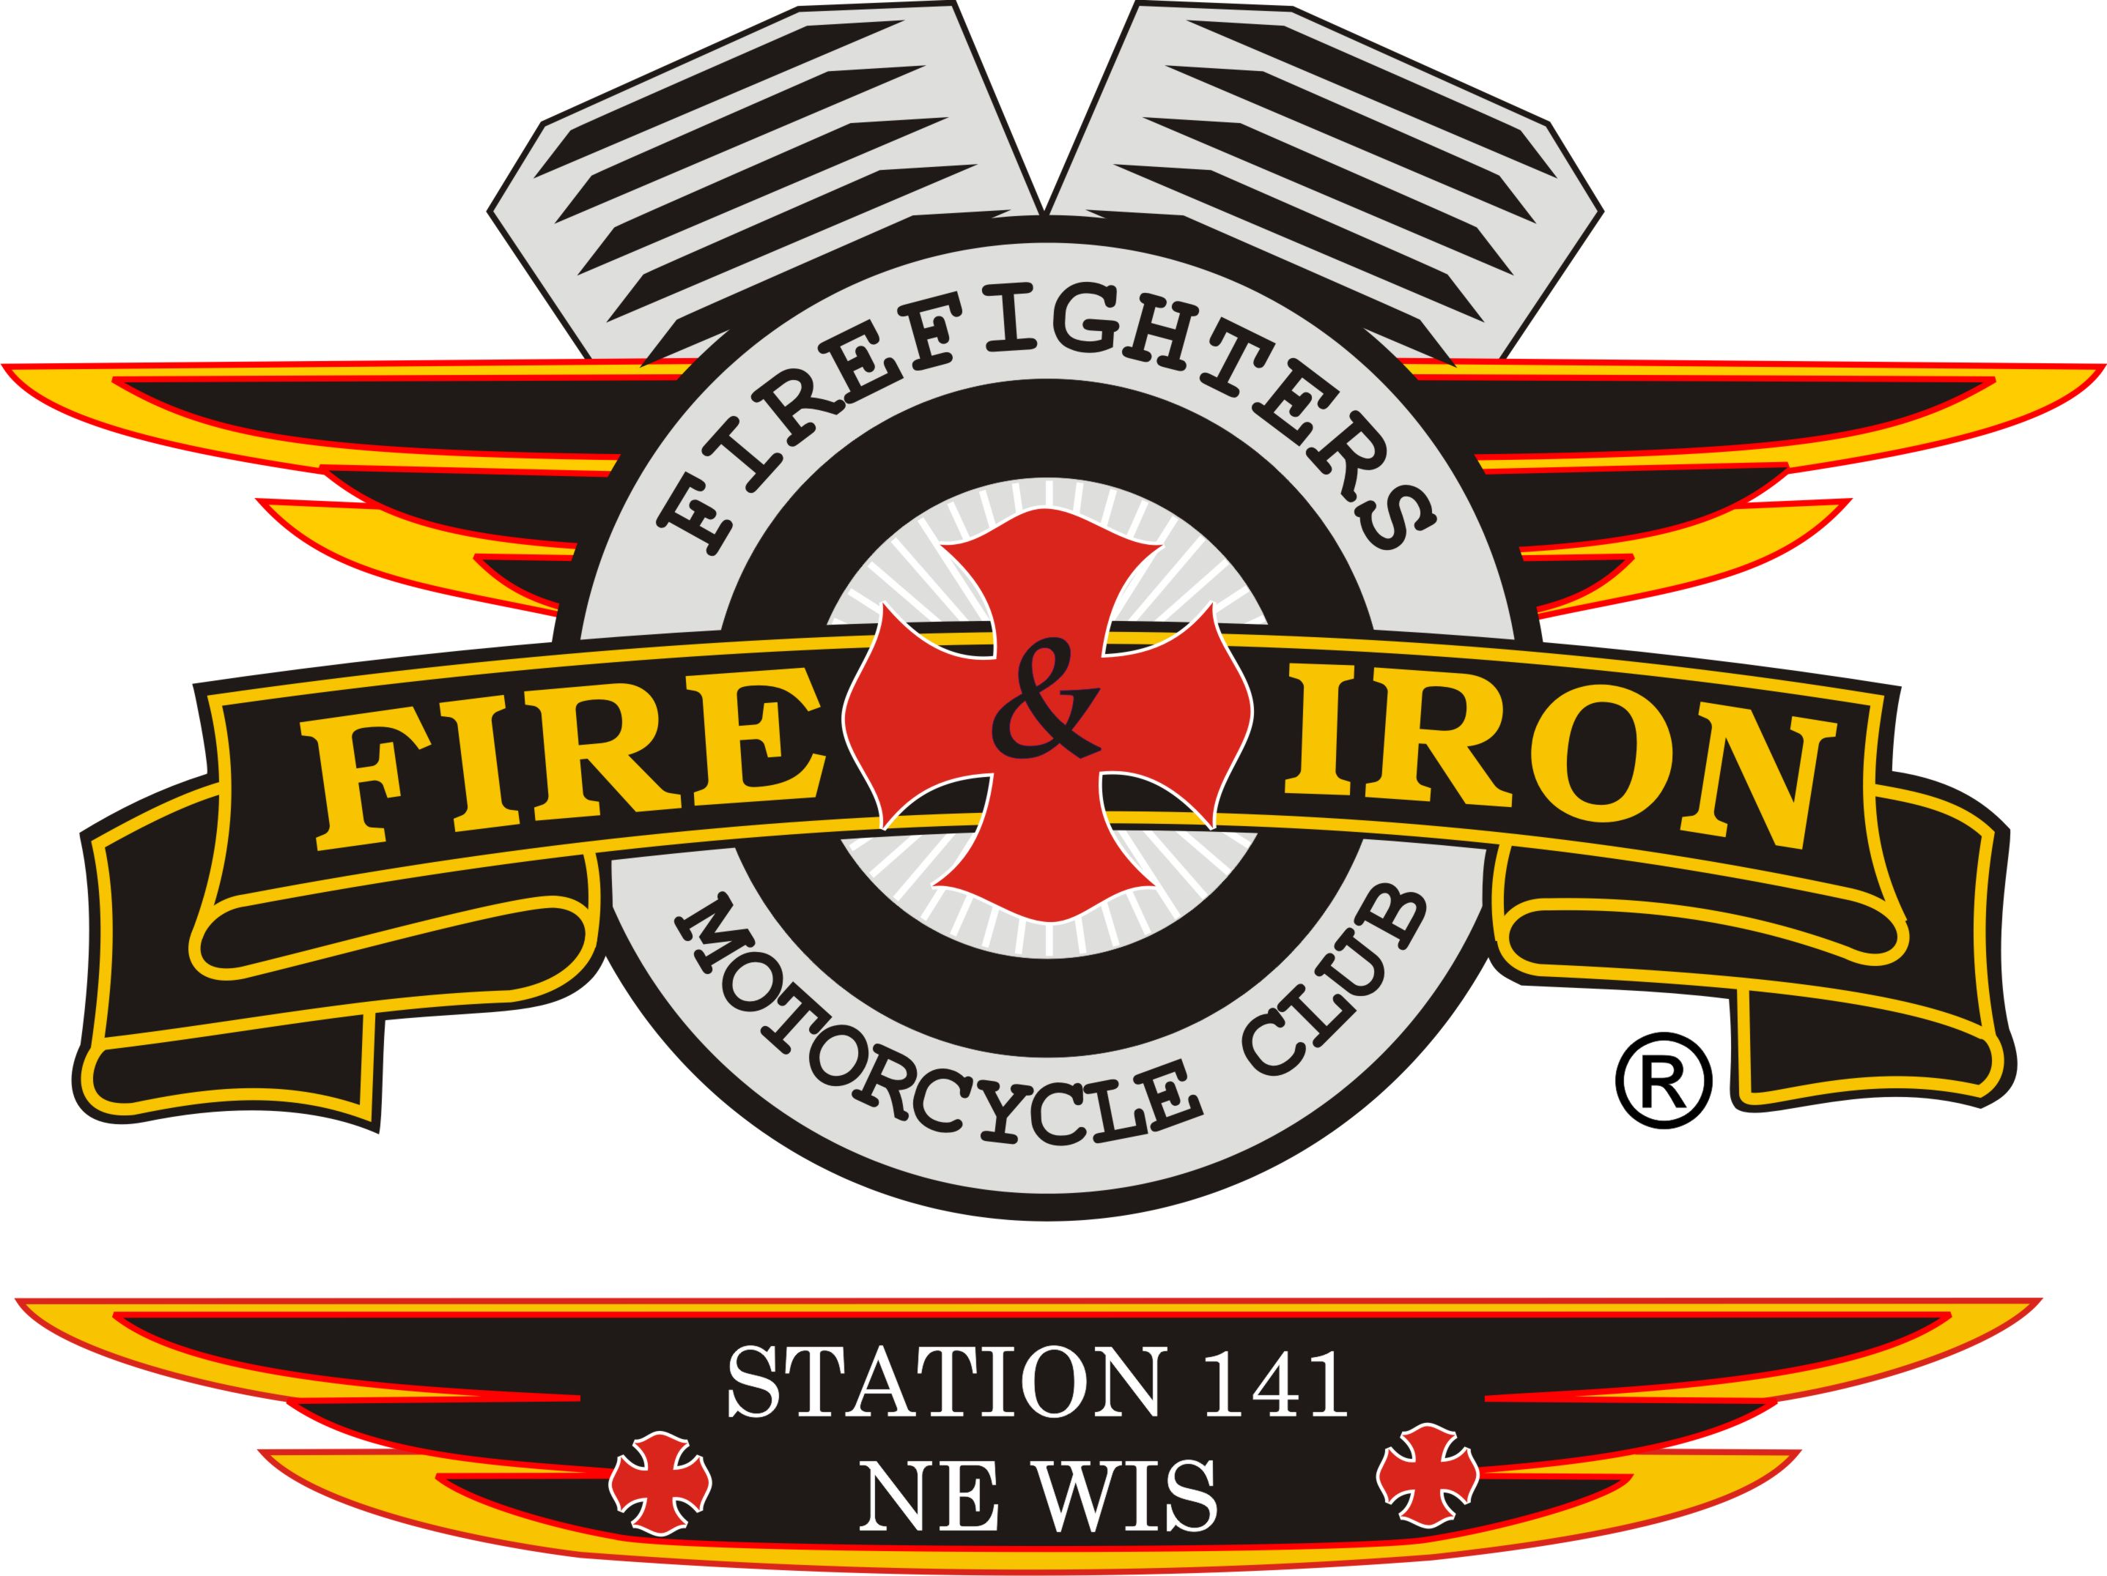
Fire and Iron

M.C. Station 141

Meeting Agenda

October 21, 2014 GBFD

- Call to order By: President John L

- Attendance: John, Tassie, Keith, Roxanne, Luke, Ozzy, Jason D, Wayne, Dan M, Curt, Timmy, Whitey2

- Secretary’s report
- Approval of minutes from last meeting: August Minutes-No September Meeting due to ride
Roxanne made a motion to accept the minutes as read and Curt 2nd, motioned carried
- Upcoming and past events
PAST
- Aug 26- Club Ride-Mayor leading – 64/32 to Mountain-stopped at Klaus Lake for supper. Great ride!!!
- Nicole Frye Ride-50 bikes. (Rolling Thunder sponsors this ride)
- Sept 27-28- Club Ride-Keith leading. Manitowish Waters, Little Bohemia and the Beef O Rama. Colors were beautiful
UPCOMING
- Oct 25- Club Ride-Wayne leading. Meet at Seymour Fire Dept.-leave at 11am – heading towards Iola
- Nov 1- Jack Frost Ride Vandervest- Meet at Gilligan’s at 10am
- November- someone come up with something for us to do
- Dec 20th-Club Christmas Party at Timmy and Donna’s house. 3pm starting time
- Jan 31st- 17’s Tree Burn-
- June 26-30th-Region 2 Rally and President’s Meeting-Station 370 Michigan hosting
- Treasurer’s report-Roxanne
Club Account:
Opening balance: 6063.82
Expenses: 214.45
Deposits: 156.00
Ending: 6005.37

Ride Account:
Opening balance: 28015.74
Expenses: 20737.55
Deposits: 20631.49
Ending: 27909.68
- VP report- Keith nothing to report
- Sergeant at Arms report-Ozzy nothing to report
Note: We have all patches and rockers from our most recent members that left.
Keith will contact Deanne about her large patch-she can either give back or just pay for it.
- Ride to Remember
Timmy received a donation from Vandervest fro $500 for our ride
He also received a donation for the Packerland 141 Hog Chapter for $100 for our ride also
Tassie will get thank you cards to Timmy for them
New business
- Region 2 Officer Election- Shawn Priddy (Repeater) current officer running against Richard Ratza from 247. Region 2 will be contacting John on what our input is for the vote
- Merchandise-Quality Ink in Luxemburg. 12 items need to be ordered each year or we will have to pay for a set up charge. Perhaps we can get a catalog. Nick is handling our merchandise from now on
- Decals-Ambrosus Graphics and Window Tinting ( Rick Ambrosus owner)
Keith has prices for different sizes-this includes our colors and our rocker-high grade heavy vinyl-like the ones Keith has on his trailer
4 inch- $3.62 each for 25 of them
10 inch- $6.27 each for 25 of them
12 inch- $9.22 each for 10 of them
18 inch- $15.09 each for 10 of them
- Next year’s ride: Wayne, Keith and Timmy to get together to figure out which direction to go this time. Jason D is going to talk to Wylie the bar manager at Duzi’s to see what they can offer us as a potential place for it.
- License plates-no one was interested
- New Probate Station in northern Illinois or east of Station 77
- National Rally St Louis 2016- June 21-25
- Lost 2 stations- 1 in Arizona and 1 in Mississippi-both left in good standing
- Received a Thank you from Jerry Parrins
- Old business
- New coin design- need ideas looking at doing a die cut cast. Keith will work with whoever wants to help
Cheese head, Lombardi trophy on it, flaming skull with cheese head hat. G logo
- Meeting date: should we go back to 2nd Tuesday or stay at the 3rd Tuesday of the month. Decided to leave at the 3rd Tuesday as we are now.
- Discussed getting 1 vest to standard- 30 days to get this done
- Giving of the Pacifier to Jason D for having short legs
- Next meeting location: November 18th -Jason D is checking at Duzi’s to see if they can accommodate us
Adjournment: 8pm- Curt made a motion to adjourn, Mouth 2nd-motion carried

