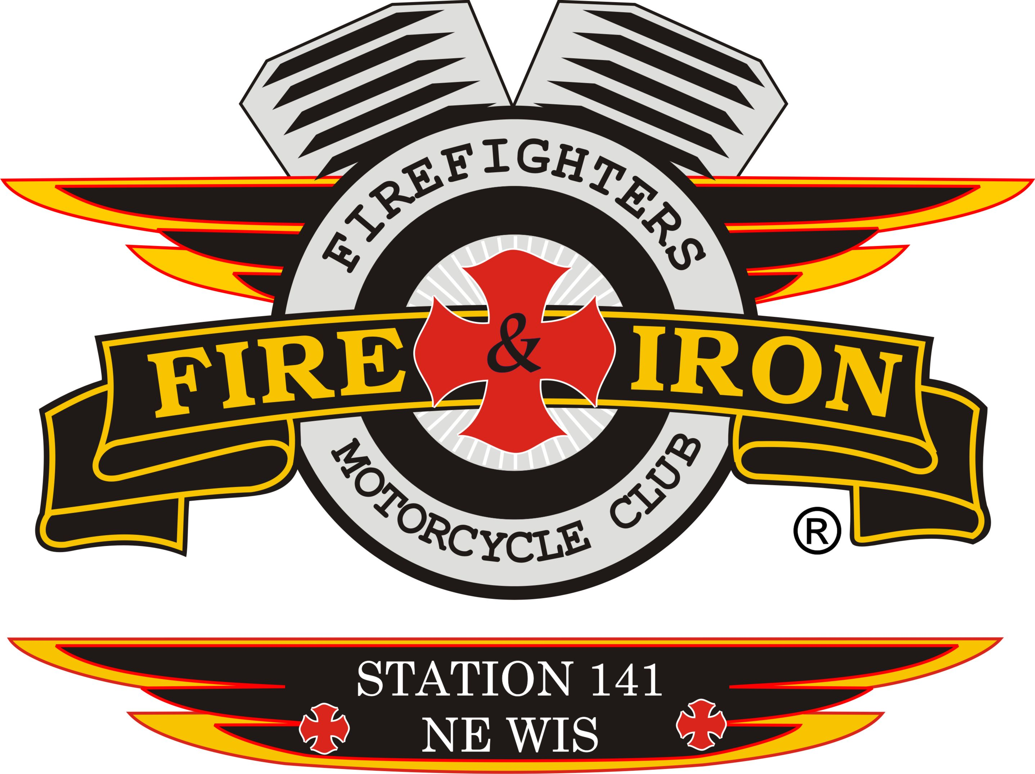
Fire and Iron

M.C. Station 141

Meeting Agenda

February 16th- Watering Hole

- Call to order By: President Nick Neabling

- Attendance: Nick, Whitey, Ozzy, Curt, Mouth, Timmy, Wayne, Jason D, James, John, Jim K, Jimmer

- Secretary’s report: 2 changes from January minutes-Ben Goodstein is running for National Treasurer not National Secretary. Motion was made to pay for 1 hotel room for Region 2 Presidents meeting for 2 nights (President, VP or whoever attends) on even year not National Rally year as was previously stated.
- Approval of minutes from last meeting: Motion to accept by Ozzy 2nd by Curt Motion carried

- Upcoming and past events
- See attached sheet

- Treasurer’s report: Motion to accept by Mouth 2nd by Jason, motion carried
Ride Account:
Beginning Balance: $33,625.62
Expenses: $240.00 (Storage shed rental)
Deposits: $20.00 (2 t-shirts)
Ending Balance: $33,405.62
Club Account:
Beginning Balance: $5951.28
Expenses: $ 0
Deposits: $69.00 (check from Nick for 2 shirts, 2 coins, &used colors)
Cash Deposit: $168.00 (sale of 14 coins)
Ending Balance: $6,188.28

- VP report: NA
- Sergeant at Arms report: NA
- Ride to Remember update:
Committee members-
Co- chairs: Tassie and John
Entertainment: Wayne
Raffles: Wayne
Route: Timmy
Opening ceremony: Keith
- Bellin is no longer a sponsor
- Greymont-possible large sponsor
- J.J. Keller-possible
- Randy Boni block??

- New business
- Club is paying for Bowling Team for the tournament
- Accident Scene Management- April 23-24

- Old business:
- By-laws were read and voted on. All accepted that were in attendance. Tassie to send out copy.
- Banking situation for club is very confusing. Will make changes when Willie and Tassie come home. Due to needing their signatures for account card
- Donation committee: Luke and John interested. Luke will be on committee
- Merchandise: Curt will now be in charge of for the club

- Next meeting location: March 15th-Seymour Hotel

- Adjournment: 1st by Mouth 2nd by Curt motion carried

