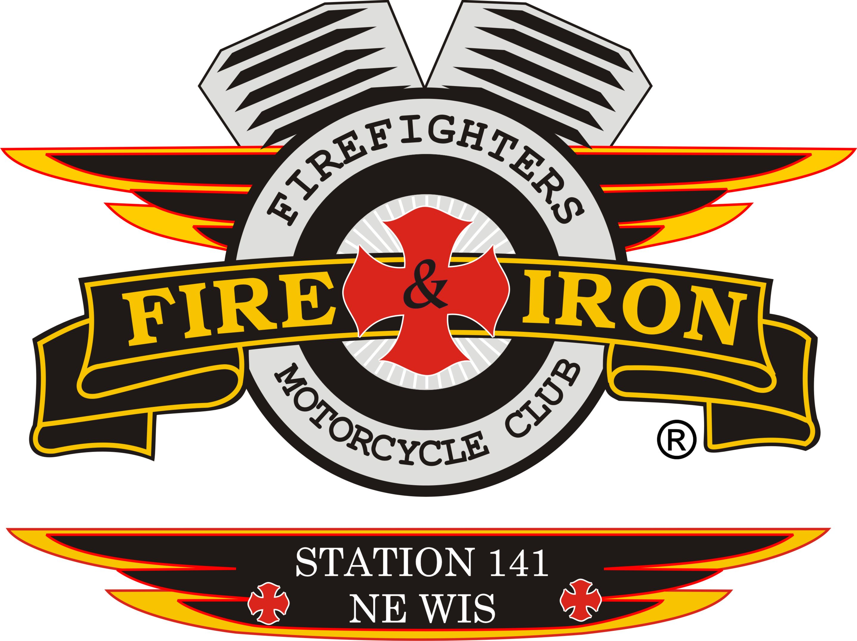
Fire and Iron

M.C. Station 141

Meeting Agenda

January 19,2016

- Call to order By: President Nick Neabling

- Attendance: Nick, Whitey, Nicole, Curt, Ozzy, John, Roxanne, Jim K, Wayne, Timmy Jason D, James, Luke, Mouth

- Secretary’s report
- Approval of minutes from last meeting: Motion to accept by Luke 2nd by Torch Motion carried

- Upcoming and past events
- See attached sheet

- Treasurer’s report: Motion to accept by 2nd by motion carried Nothing in notes for motion and 2nd
RIDE ACCOUNT:
Beginning Balance: $33,129.61
Expenses: $3.99 (Bank Fee)
Deposits: $500.00 (Kohl’s Donation)
Ending Balance: $33,625.62

CLUB ACCOUNT:
Beginning Balance: $6450.88
Expenses: $29.00 (Club Patches)
$470.60 (Christmas Party)
Deposits: $0
Ending Balance: $5951.28
Month to date: (1 RTR black shirt $15, 2 old blue ride shirts $5)

- VP report: Nothing to report

- Sergeant at Arms report: Handout of By Laws with Article X and XIII highlighted. Grievances and conduct of members. We covered this back in August-Social Media.DO NOT ENGAGE in comments and remarks made by members that are negative. We are to PROMOTE F&I ONLY. Negative comments are childish; we are all friends with each other and with people at other stations, sponsors and community leaders. They all see what is posted and members have worked too hard to lose these sponsorships. SOA will discuss if there are issues between members and posted items. If you see anything negative report it to Ozzy and let him deal with it, DNE. Bad standings will be handed out if this behavior continues. Again, we are all adults, ANY ISSUES NEED TO BE BROUGHT TO SOA, ALWAYS.
Starting today with a clean slate. Decisions of punishments on bad standings means the following:
- No club events
- No meetings
- No voting for at last 60 days, case by case depending on severity of the deed.
- If you haul off and punch someone, that is immediate
- Other items less severe, Follow the By Laws

- Ride to Remember update:
- Wayne, John and Ben had a meeting today. Went well, discussed concerns on drink prices going up when the bad plays. 141 is paying for the band so Ben committed to keeping the drink prices at the normal price with no increase.
Move the start time for the band to 5pm, start playing right after ride. We would like to be done by 9pm this year; Ben will book a different to play after our band is finished. If we go over the determined amount we set for the band, Ben will chip in $200.00
Entertainer Ad- ad should have been much bigger then it was. Should have been a 1/4 to ½ page but was considerably smaller. We will do the ad ourselves this year / split page with Ben. Wayne will take care of.
- John will start contacting sponsors this week
- Kilts and colors upstairs the same as last year. Hotel and ride ending at Watering Hole. There was positive feedback on kilts and colors and hotel.
- We need to decide on a band and how much we are going to spend. Cougars are the hottest band around the area right now. Last years price was $1500 for 4 hrs. $140 an hour after that. Motion by Roxanne to have a $2000.00 band cap for our portion of 1 band. Ben will chip in if extra is needed. 2nd by Luke. All in favor, motion passed.
- Timmy has ride route going from Ellington 1st then to Marion, on to Nichols and back to GB. Hobart police OT will cost us $400 if we use them due to County J by Oneida back to Watering Hole is their area. Timmy will talk to the Police Chief and see if we can black ourselves and then not have to pay the fee. Luke will ask the FD to block for us one hour the day of the ride.
- Official ride date was given to Hustler and to B&W.
- Sponsors: John will get Nick a list of sponsors and new letter for us to use to start getting donations Let John know if you want to be on the ride committee. Last year there was Keith, Tassie, John, Roxanne and Curt. They would like everyone to help. Roxanne will take care of donations as in the past but will not be on the committee.

- New business
- National Elections: Primaries.
Nick spoke with Dana Phillips running for National Treasurer. Dana is looking to start sending quarterly reports of where the National money goes.
Match- running for National VP flew in from MA. He would like to see the club grow but yet to continue in the same direction it is going. Keep it uniform and organized.
JD spoke with John about anyone interested in running against Pauly. JD accepted running for VP again due to finding others to run against Pauly, otherwise JD was going to do it. Pauly is running on what he has done in the past, he maintains the National website, sends out correspondence, Region 2 feels they deserve to have a member on the National Board to fight for us.
Redneck is no National Secretary material. Ben is running for National Secretary, has had a change in his workload, so can contribute more time to the Club again.
Nick asks that you go thru the emails on candidates and if you have any questions let him know so he can answer them for you.

- We have 1 probationary station in Region 2, Station 67 out of Northern Illinois. Station 46 disbanded, 1 member went to Station 17 the other to Station 37. One Station in bad standing-Station 49,E River SD, they are 2 years behind on dues, they are disbanded, it just hasn’t become official yet.
- National Rally-314 Metro is having identical rides on Tues, Wed and Thursday due to the volume of traffic in St. Louis, we can not have large groups. The National ride will be short. Thursday is the President’s meeting. There will also be a Ladies ride one of the days. There will be a Brewery Tour however, you will not be able to ride to that, a bus will be provided. Register soon for the Rally as the money that they get in for registration is being used to pay for the venue expenses. Daily rates are available if you can’t make the whole rally. FISTL314.com is the website. THERE IS A HELMET LAW FOR MO!!!!!!
- National colors are for members ONLY. “Fred the Head” is being trademarked. National wants back all colors, T-shirts, sweatshirts, coins and such if you leave F&I. They will be buying back all back patches from here on forward, if we need any we need to contact them. They are trying to keep everything together and uniform. We will need to purchase rockers from someone else
- National Benevolent Fund helps members in hardship and death. Funded by National dues we send from all stations. They discussed raising the cost of colors, club dues to $200 for each station, charge by per person per station, put out a coin, patch or t-shirt to raise money for this fund.
- Money given to National is used for fee to maintain web site, domains and lawyer costs, travel within the region. Pauly also uses money to buy back F&I items on EBay and other websites along with anything found at Goodwill
- Wayne brought up bowling tournament in March, 18,19 and 20th. $20 per person. 5-person team, we need to sign up now or we won’t have a spot in it.

- Old business
- JANUARY CHANGES TO BY-LAWS:
- Description of Secretary: 2nd bullet point down-add the word “of”
- Article 3-Membership that has to do with time considered being a retired member. National By-Laws state 5 yrs. Station 141 says 10. Amend to: Station 141 will change from 10 to 5 years the same as National. This change is proposed due to moving, change in borders of fire districts, keeps good people coming in
- Article 6-Election of officers. November elections-the new officers elected take over January 1 of the following year. Amend to: Commence duties at the adjournment of the November meeting. Prevents any danger to the club due to bad feelings, if any, due to change in position.
- Article 8- Monthly station meetings the 2nd Tuesday of the month. Amend to: 3rd Tuesday of the month, unless otherwise directed by the President of the Club.
- Article 8- Attendance. Definition of what a meeting is: Meetings are to include a club meeting, a ride meeting and an officers meeting to make 75% of required attendance for meetings.
- Change in disciplinary procedure at the bottom of page 15:
3 Step Process:
2/3 vote from Executive Board for verbal
2/3 vote from Executive Board for bad standing
2/3 vote from all attendees at the station meeting that the disciplinary action is brought to attention for removal from the Club.
- Torch made a motion to add: here on forth the Club will pay for the President and one (1) member of the board for the President’s meeting hotel room on the even odd calendar and for the National Rally on the even calendar year. Room is for 3days/2nights, double occupancy. NICK I REWORDED THIS.
Motion by Torch, 2nd by Luke. All in favor-no 1 opposed. Roxanne MOTION CARRIED
- Donation of Club money for various things:
- No voting will be done via email, though good intentions were there it was not handled properly.
- Pres. Nick read letter from Sarge (Station 131) to the Club. Money from the Club to Sarge for funeral expenses was discussed. John spoke about the funeral for his daughter. Ozzy to John- brought up benevolent fund of our own. March 2014-That motion is in the minutes to donate to Club loss.
- John: Oct 2010 meeting at Stadium View. Randy and Lynette Dunn and Slushie were in a crash. A lot Dr. bills. Donation at that time was shot down. If we start donating to every person, where do we stop? Decision was made to not donate to everyone who has a bike crash, cancer or loss. Money was collected from individual members and was brought down to the funeral, but not club money. Members of our Club who didn’t get donations.
- Wayne: Sarge is asking for our help. I can’t imagine the balls it took to type that message and then send. We need to look at holding funds back from the Burn Camp fund and take care of our own first.
- Ozzy: Tips from July 4th go into our own Club account and could be used.
- Jason D: If a brother comes to ask for help, we help them. PERIOD
- Roxanne: We can’t give to everyone. Where do we draw the line, we will create hard feelings. If person A finds out the we gave, and then they had a loss, and we don’t give to them it’s going to create animosity.
- Mouth: I make a motion to do a $200.00 donation to Sarge for the coverage of funeral expenses for his daughter’s passing. Roxanne: Revised motion to give but to not set precedence. Mouth: Motion to do a $200.00 donation and from here on forward we vote on it as a Club on a case-by-case situation. 2nd by James. All in favor-motion carried.
- Donation Committee-Nick is stepping down. James and Jason D are in. Luke and John asked to step up.
Tables until next meeting discussion/decision. Choice needs to make by Pres. Nick as to which member will join James and Jason D.
- Black Otter Event- Good event-hoping there would be 40+ people, but due to bad weather ended up with 25.
- James: After dinner at the Black Otter Event they went to Hero’s Bar in Hortonville. They have ceiling tiles that you can purchase for $35.00 donation; they paint it up with whatever we want on it. Good advertisement. We will collect money at the next meeting to purchase a tile out of our own pockets.
Tabled until next meeting and the Fire boot will be there for donations.
- Margie’s Remembrance, Station 11 passed from cancer, Nicole spoke on how the Club and family appreciated the travels in from the 7 Stations that showed.
- Merchandise-No call back from lady. Embroidery is done at EJ Arena and Printing from Eagle Graphics.
- Signature card- we need to SS# and Drs Lic photo copies from all board members prior to getting a new signature card due to federal regulations. Nick will call Capitol Credit Union to ask their policy. Ozzy suggested we change banks.

- Next meeting location: February 16th 2016- 7pm

- Adjournment: 1st by John 2nd Luke motion carried. 9:10 pm

