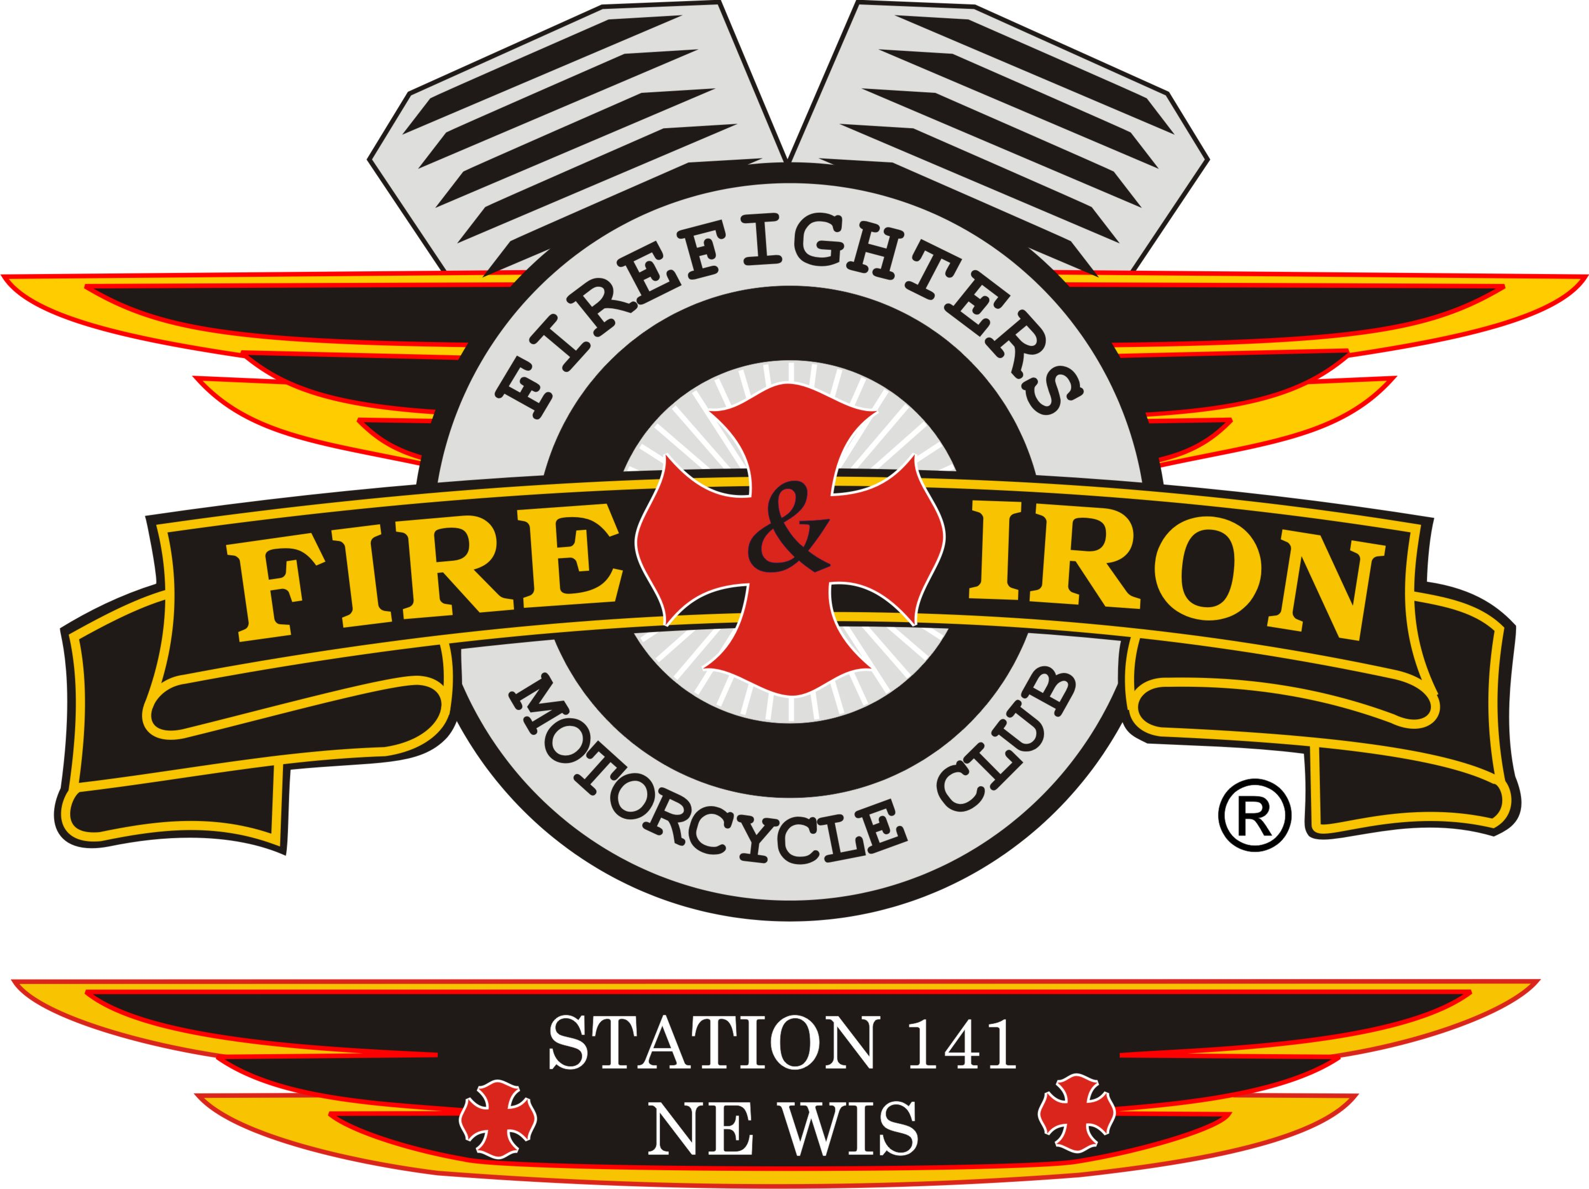
Fire and Iron

M.C. Station 141

Meeting Agenda

August 30th- Watering Hole

- Call to order By: President Keith

- Attendance: Keith, Tassie, Whitey. Ozzy, Slushie, Deb, John, Jim K, Luke, Tim A, James, Tom D, Timmy, Mouth, Curt, Wayne, Jason D, Zach W, Barry M

- Secretary’s report
- Approval of minutes from last meeting: Motion to accept by Luke, 2nd by Curt Motion carried

- Upcoming and past events
- See attached sheet

- Treasurer’s report: Motion to accept by Jim K, 2nd by James. Motion carried

- VP report: 1) RO 2 Officer: Shawn (Repeater) is not running. 2)July 4th- haven’t gotten anything back yet on what we made yet from the sales, will contact them shortly if I don’t hear anything. 3) Sponsored people can not sponsor others to join.

- Sergeant at Arms report: Slushie-Thank you to the Executive board for asking me to be the SA. Remember, no one outside of our club can wear our colors anymore, this includes t shirts etc.

- 50/50 Raffle- sell tickets

- Ride to Remember update: Fri- James, Whitey and Mouth to go and sweep route
Entertainer-Wayne shared the ad for the ride-Looks great. Runs for 2 weeks. Partially donated, we owe $125.
Wayne also got the Seymour paper to run our ride and they did it for free
Tassie to send check to band so they are paid for ahead of time
Whitey to get start up cash
Dropping the price of t shirts so we can get them sold
Tassie’s sister donated thru her Thrivent acct a $250 gift card to Doc’s

- New business
- Need to find ways to send info home to families in our areas about the Burn Camp
- Ordered 300 can cozies-about $1 a piece
c) We need to vote on VP and Treasurer-nominations at September meeting. Vote in November.
d) Regional Officer Nominees: Chris Drews,Ric Radsaw, Ryan Leavitt, John “Hustler” Herman- we need to provide 2 names by next meeting .
So far Hustler is the only one that has contacted our President.
e) Nicole Stuart who left our club in May contacted Pres Keith and asked if she could rejoin. He told her she would have to wait a year per the by-laws and would need a sponsor. Said we would just wait a year to see what happens and let everything settle otherwise yes.
f) National By-law are due- check them out, any changes needed get them to Keith by next week.
g) Zach Webster who visited us last meeting has joined – Welcome Zach
h) Barry Miller also joined tonight- Welcome Barry

- Old business
a) Charleston 9 Memorial is moving forward
b) By-law that we had tabled in regards to how we handle when executive board changes are made is not resolved due to by-laws coming due
c) Keith>shirts

50/50 Raffle winner: Tassie $33

- Next meeting location: Watering Hole September 20th 7pm. We will also do a ride wrap up meeting.

- Adjournment: 1st by Curt, 2nd Jim K, motion carried

