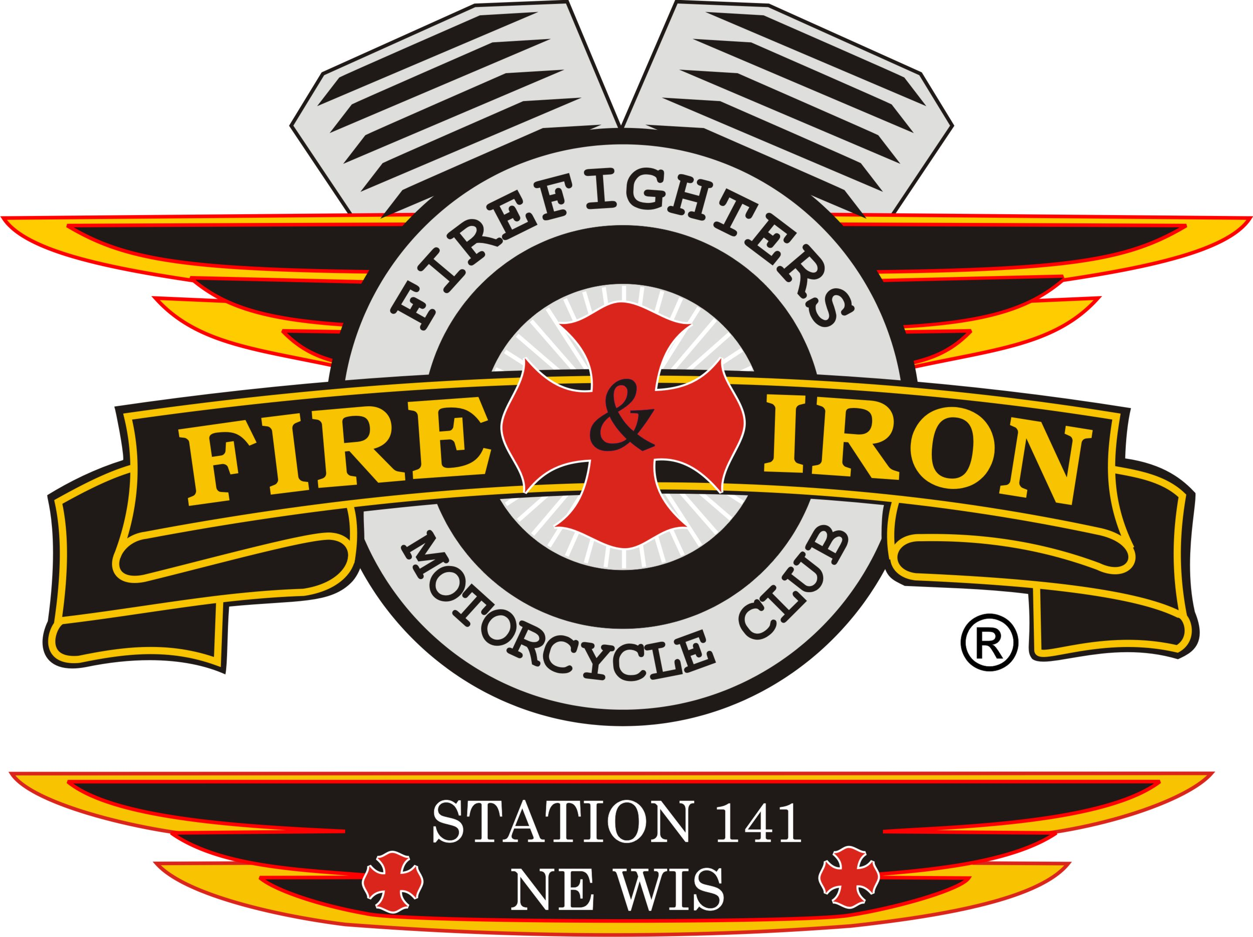
Fire and Iron

M.C. Station 141

Meeting Agenda

June 21st-Jackson Point

- Call to order By: President Keith

- Attendance: Keith, Tassie, Whitey, Ozzy, Deb, Slushy, Torch, Tim A, Jason D, Wayne, Jim K, James and Luke-potential new member Tom

- Secretary’s report
- Approval of minutes from last meeting: Motion to accept by Luke 2nd by Torch. Motion carried

- Upcoming and past events
- Pass around sheet-Bud Tent- They are honored to have us and ready to go

- Treasurer’s report: Motion to accept by Jim K 2nd by Torch. Motion carried. See attachment

- VP report: 4th of July bartenders are signed up.

- Sergeant at Arms report: Discussions are still taking place with several folks yet

- 50/50 Raffle- sell tickets: Whitey to add the amount we take in on the financial sheet

- Ride to Remember update:
Vans are reserved to take kids to and from burn camp-Tassie and Keith will drive kids to and from. Anyone else wants to come along. Tassie and Keith need to apply for position thru Burn Camp so they are covered for insurance reasons.
Met with Ben to solidify the Watering Hole-no price increase on drinks
Food will be available the same as last year.
Posters and banners
Dart Insurance has been contacted but need the stops and any place we are blocking. 2 stops-Ellington and Nichols- no blocking by us
Wayne- did you do the contract with the band? Nick does not have the contract, but Wayne contacted Bananas and we are good to go.
Did the club decide that we should not charge at the door to the band? I have nothing on this in the notes. We will put some boots out but will not charge
AmericInn West- 10 rooms have been blocked off for the ride-920.434.9790. Queen room $79, King room $89
Wayne raffles: tickets $5 each or 6 for $20. 5 buckets, 1 will be a mystery. We also have the quilt to raffle

- New business
- SA needs to be chosen- in progress

- PayPal- John and Keith need to switch account over. Nick does not have any information in it. Check with John again. Keith also needs mailbox key. Nick does not have, Whitey does not have either.

- By-laws change-read and discuss- amendment to positions> Article IV.
- 6/27/16 The Executive Board is going to have more discussion on this amendment before we vote on it as a station, it may be reworded/edited. More to come for next meeting. Station 141 has invoked the following: In the event of an officer leaving his position permanently/leaving the club the process to fill the position will be as follows: Officers will move up in rank/position but also must follow the criteria laid out by National by adhering to the need to be a “Primary” member for President and VP. VP moves to President, SA moves to VP. The Executive Board will meet to discuss how to fill any other positions such as how to then fill SA, Secretary and Treasurer in the event it is needed. The positions will be held until that position comes up for election the next time
Note: we talked with Repeater Region 2 President about how to proceed on this change. Majority at meeting ratifies it. Does not need to go to 3 meetings to be accepted.

- Luke does not have a club name yet
- Slushie said he will sell coins at National-8 coins from Keith
- Tom Diedre came as a guest with Ozzy to check our club out

- Old business
- Paid 2016 Logo User fee from our personal account-need to be reimbursed.
- Our accounts with First Merit are all set up- 2 cards for Keith and Ozzy each.
- Tassie purchased recorder for meetings. Need to pay her back-done
- Keith still needs to contact Black and Whites-difficult to do. - Ben and Chicago Paul said they would help this along
- National attendees-Ozzy, John, Roxanne and Slushie
- Torch- print outs for merchandise- will have 6/22
- Tiles for James is paid for
- Hand out posters
- Wayne and Timmy ran the ride route-brand new blacktop roads should be a sweet ride
- When you need to block and wear a safety vest, you do NOT put it over your colors/cut. Take your colors/cut off put it in your bike or away. NEVER cover it up.
- Wear your cut when you go on rides; be proud of your Club!!!
- Coin challenge, how close does your coin have to be? 3steps/arm reach away/ Any Fire and Iron club coin can be used. No plastic coins.
- Ellington has water fights the day of the ride, if anyone wants to get a team and represent 141 please do!
n) Should have water fights at National Rally-someone suggest this…

50/50 Raffle winner: Wayne won $22- the rest goes to the Christmas Party fund

- Next meeting location: July 19th- Luke volunteered for Hobart and will plan a ride to Pulaski. We also decided that August and September meetings should be at the Watering Hole

- Adjournment: 1st by Tim A, 2nd by Torch. Motion carried

