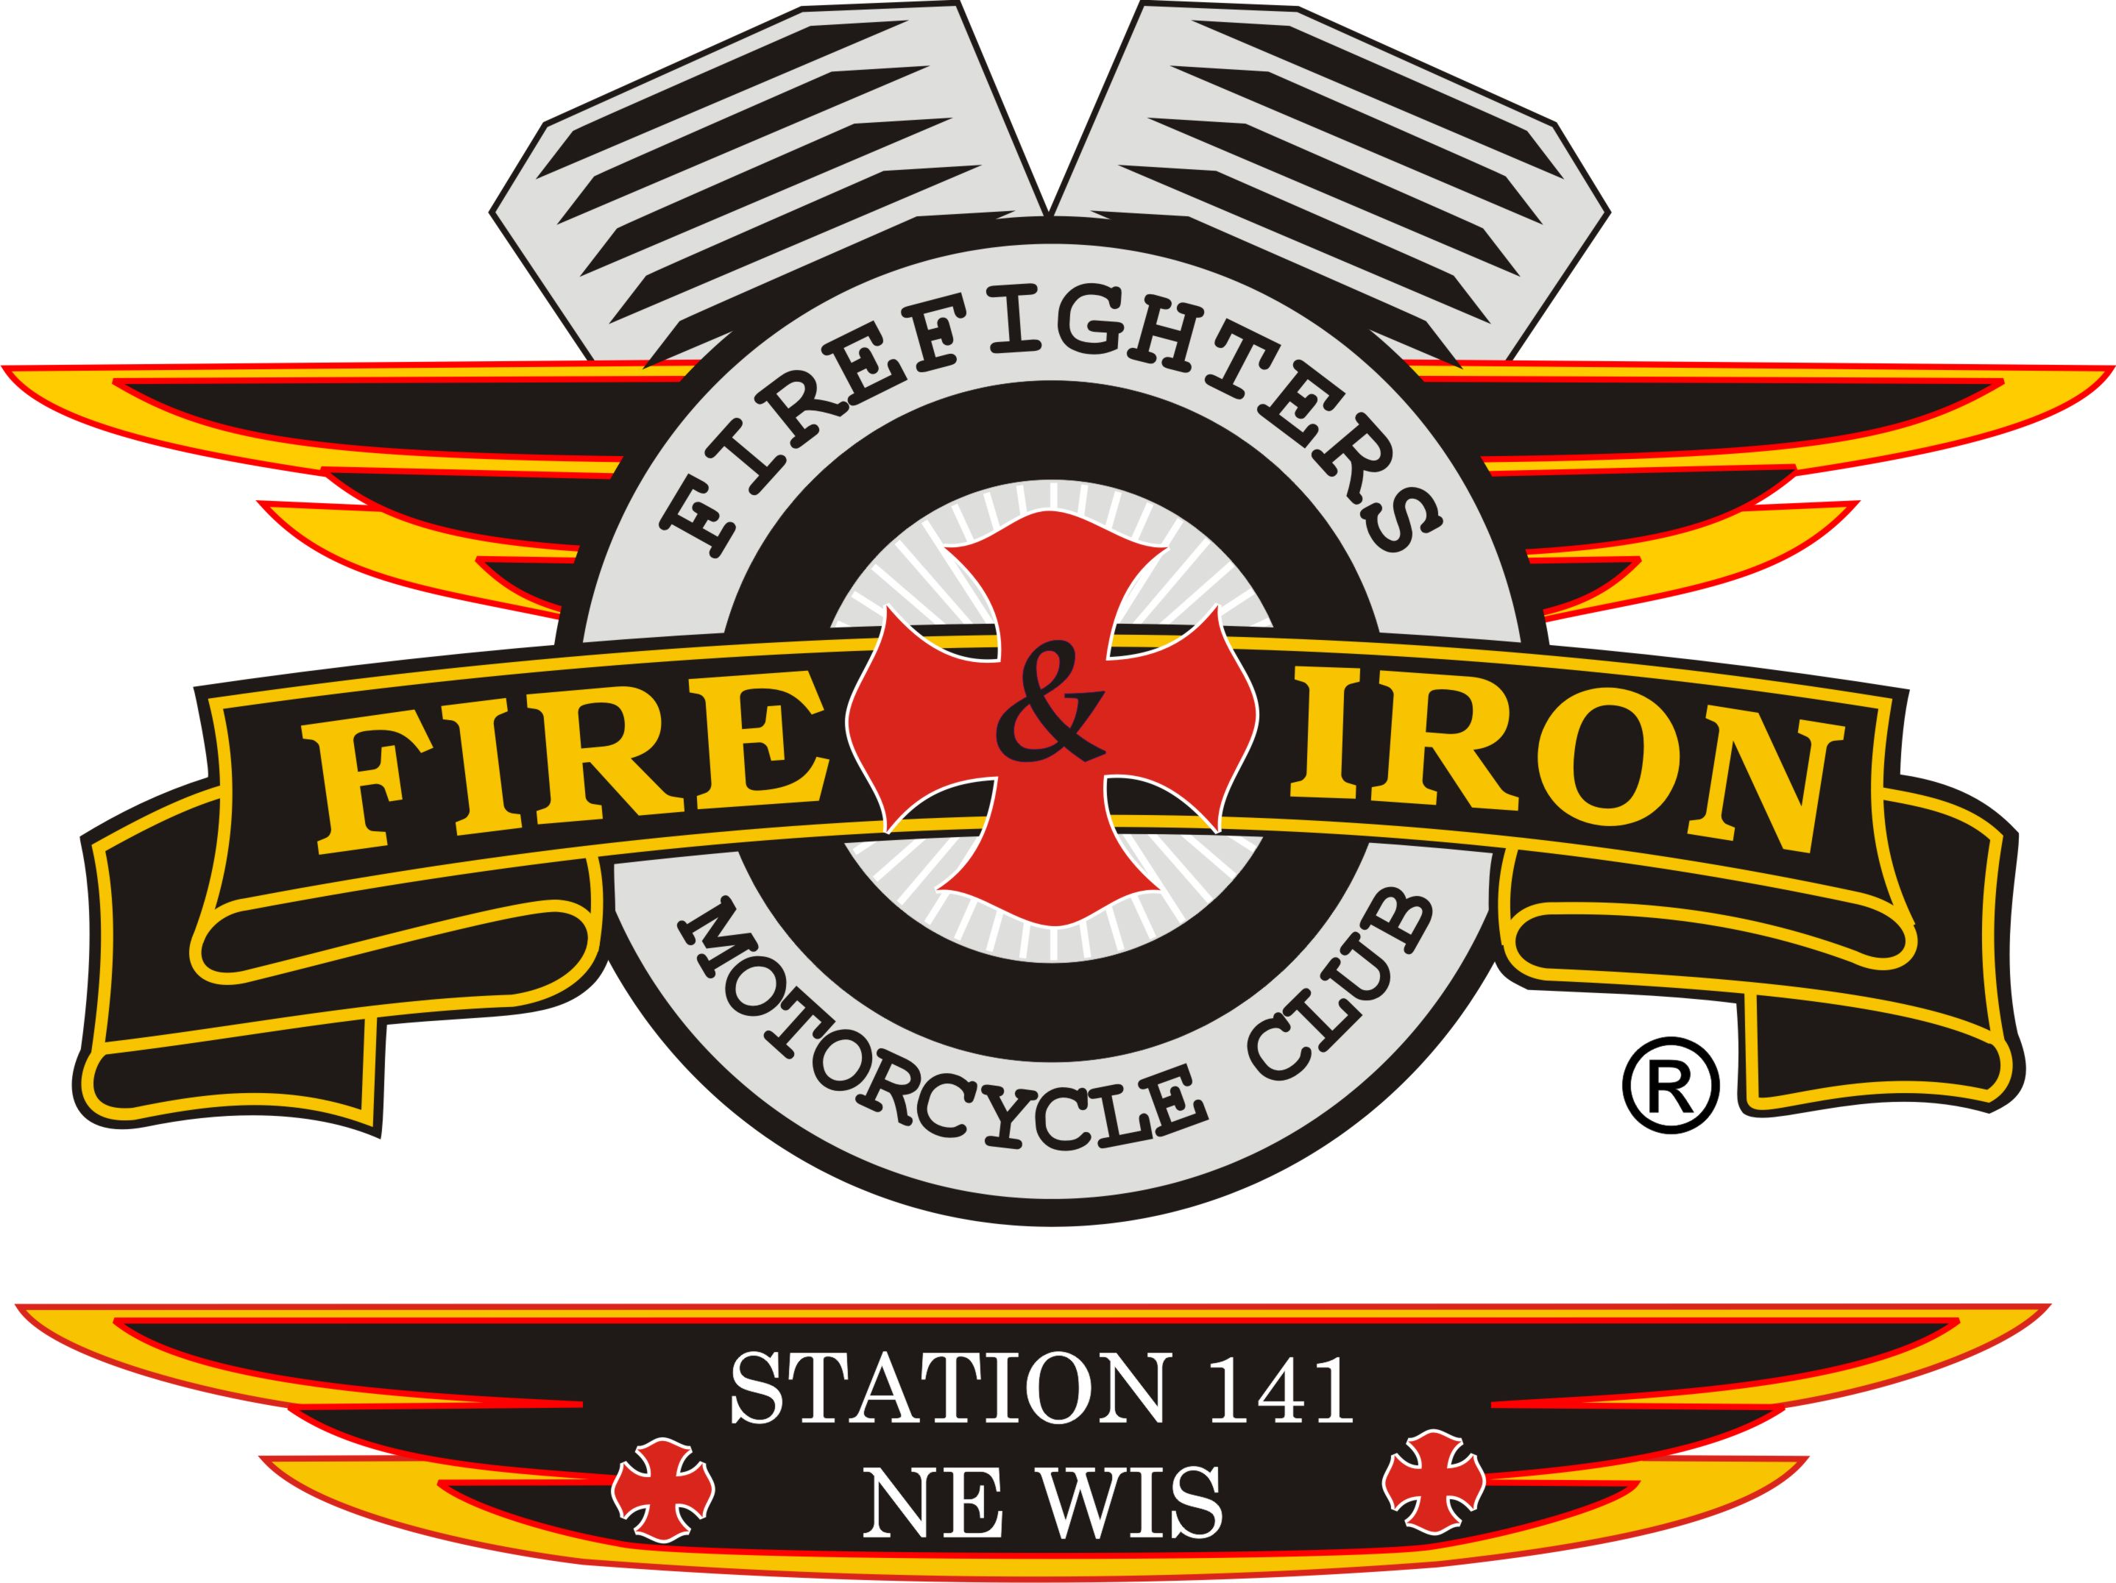
Fire and Iron

M.C. Station 141

Meeting Agenda

August 18th – Watering Hole

- Call to order By: President John L

- Attendance: John, Tassie, Keith, Nick, Ozzy, Nicole, Roxanne, Curt, Jimmer, Jason D, Slushie, Deb, Whitey, Tim A, Luke, Jim K, James,

- Upcoming and past events – see event sheet
Burn Camp Update: Number of children riding bus was down this year, which hopefully is a good thing.
Burn Camp Media Day: Keith, Tassie, Ozzy, Nick, Nicole, Whitey (did I miss anyone?) Nice ride and great time. Beautiful layout and parade in. 3 helicopters, lunch, entertainment.

- Secretary’s report
- Approval of minutes from last meeting: Motion made by Luke 2nd by James motion carried
- Treasurer’s report: Motion made by Roxanne 2nd by Luke motion carried
Ride Account:
Beginning Balance: $32,513.58
Expenses: $14.10 (7/21 Reimbursement postage)
Deposits: $0
Ending Balance: $32,449.48
Club Account:
Beginning Balance: $3952.21
Expenses: $126.00 (PO Box Renewal)
$200.00 (7/4 startup money)
Total: $326.00
Deposits: $1938.00 (Tips from 7/4)
$1124.67 (T-shirt, can cooler sales and start up money)
Total: $3,062.67
Cash on Hand $47.00 (3coins $36,1 shirt$5,1 station tab$6)
Ending Balance: $6,735.88

- VP report: Communication-important and respectable for each other. Example: only 1 or 2 people let Luke know whether they could make it or not. What about the rest of the club? Hard to plan and again disrespectful.

- Sergeant at Arms report: Social Media-bashing of our Club and or any member WILL NOT be tolerated and will be dealt with immediately.

- Ride to Remember update:
- Ride Committee met with Howard Fire Dept. along with Timmy our Road Captain. They will offer breakfast for sale. We will have an area where the food is sold for sitting down to eat, room for our bucket raffles. HFD is also giving a donation gift for us.
- Discussion on route with HFD, blocking etc.
- Rolling Thunder will help block for our ride
- Tassie needs to add our event to TV stations Community Calendars
- We did not receive any money from Region 2 or National to help pay for our out of town Fire and Iron guests.
- We will set up on Friday, as the court is ours at noon that day.
- Total amount of large donors is $8000.00
- Everyone needs to have his or her donations in to Roxanne by September 1st!!!!!!!
- Duke FM has started advertising our ride on the radio
- Kohl’s will supporting us with volunteers as in past years along with a monetary donation.
- If everyone could share our ride info on their FB page and mention that we have a new starting place (Howard Fire Dept.) and share a few words it would certainly get the message out about where we are starting and perhaps get more people to attend.
- Dean Dist. will make a poster to put at the Neville in the event someone would show up there letting them know it starts at HFD.
- SWEEPING or the RIDE: Friday Sept 11th. Timmy is going to go out and do the Northern end after he gets done with work in the afternoon. Contact him about helping. Someone needs to do E to the south. PLEASE make an effort to help and contact Timmy so we are working together on this!!!!!!!

- New business
- Transporting kids to camp- we need to revisit this. We had a coach bus with 15 children on it. 141 has been paying for the entire trip. Look at a different route perhaps where we share with other stations or Burn Camp. If we had a better idea of how many children are going ahead of time we could use the appropriate type of transportation along with keeping the children’s comfort in mind. We would rather just give the money to the Burn Camp versus some bus company receiving it. Just something we need to keep in mind and work on.
- Next meeting location: September 8th, Watering Hole 7pm. RTR Meeting at 6pm

- Adjournment: Motion made by Ozzy, 2nd by Luke motion carried. 7:45pm

