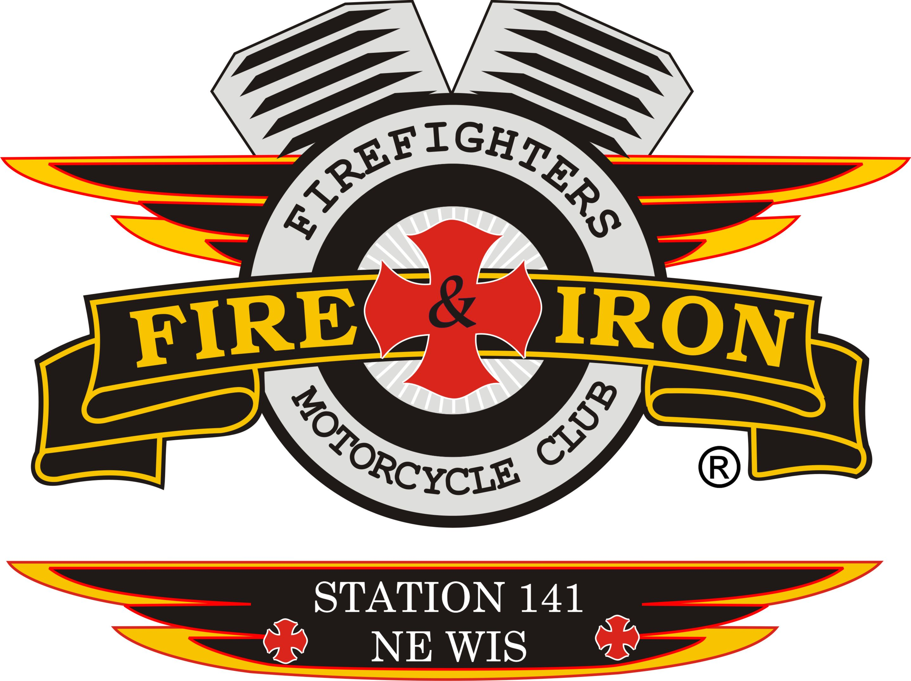

Fire and Iron M.C. Station 141

Meeting Agenda

Tuesday, June17th 2014

- Call to order By President John Lawler at 7:05 pm at the Watering Hole
- Attendance: John L, Keith W, Tassie W, Roxanne L, Wayne G, Curt V, Timmy V, Tim A, Daryl L, Steve D, Jason D.
Warren our State representative has notified John that a potential new member from Larson may be contacting us.
Welcome to new member Jim Kasik-Jim has worked on the Hobart and Brazeau FD’s and is currently on Suamico’s FD.
Whitey 2 may be returning to our membership- he has talked with John and we welcome him back should he decide to join us.
- Secretary’s report
- Approval of minutes from last meeting-Timmy made motion to accept secretary’s report and Curt 2nd. Motion carried
- Upcoming and past events
Past
- 112’s Ride on May31st-John,Rox and Ozzy attended-Station 112 plans on having some members attend our ride
- National Rally June 2-6
Great time by all-really something everyone should try and attend. The next one is in St. Louis in 2016. National election outcome as follows: Pres-Ricci, VP-JD, SAA-Bentley
John talked about vest compliance and what took place at National-if you were not in compliance you were not allowed in to the Pres and VP meeting until it was.
From here on out if a person is not in compliance it could reflect on the whole station not being in good standing.
- Jerry Parrins Cruise for Cancer-Timmy
Vandervest said it is the best turnout of bikes ever. 600+ bikes-800 people ate on the food stop. The ride went very well. Ride was back to Lambeau by 5pm. John presented a check for $500 to them. John also handed out info cards for our ride to about 500 people.
Upcoming:
- June 28th: Michael Edwards Memorial Ride-starts at Jen’s Naughty Pine.
Keith will send out a text with info on where to meet so we can all ride in together.
June 28th: Station 37’s ride-Nick and Curt are going to go and represent us.
- July 4th: Fire over the Fox – please get with Ozzy to sign up to bartend. Remember we keep our tips so this is money we can have some fun with down the road. Really need 12 or more people to work the night time
- July 12th: Station 17 who always attends our ride has their Burn Camp Poker Run. Registration is from 10-12. You go at your own pace. Let John know if you are going so we can ride into together if possible.
- July 12th: Vet’s Ride-Pearly Gates- Wayne is the contact and will be attending
- July 19th: Station 131 Sparta-Try and send someone, they have attended ours in the past
- July 26th: Car wash at Kroll’s Bar in Sobieski-Tim A and his fiancé Kim L have decided to donate the money from this to the Burn Camp. So if you can’t wash cars then take your car there to be washed.
- August 3rd: Ride for Ryan Szpredja(Roxanne’s relation)
- August 14th: Burn Camp Media Day
- August 16th: Station 56 ride
- August 23rd: Rolling Thunder Sponsored Ride
- Treasurer’s report- Roxanne
Club Acct:
Ending Bal: $1710.07
Income: $5,393.33
Expenses: $851.97
Total: $6,251.43
Ride Acct:
Ending Bal: $32,903.65
Income: $1,211.00
Expenses: $11,539.53
Total: $22,575,12

- VP report: Keith-Nothing to report
- Sergeant at Arms report-Ozzy
Mr. and Mrs. Heil’s colors have been returned. Kewaunee colors by July 1st.
John asked at the National Rally what should be done with colors that have been returned and we will burn them at some point.

- Ride to Remember:
- New sponsor: Graymont (formally Western Line) donated $1000.00
- Sent note to Cellcom and Bellin to pay their sponsorships
- Tyco is a no go this year
- Posters: John will get some to the Seymour boys
- Discussion on letting the Ride Committee make decisions and move forward versus back and forth at a regular meeting. Who is the Committee? Anyone can be on the committee. John, Keith, Rox ,Tassie, Ozzy, Wayne, Timmy and Jason have been attending thus far (Deanne had been also).
Rox made a motion that the Ride committee can make decisions on spending up to $700.00-anything over that amount must come back to the regular meeting for approval. Tim A 2nd-motioned carried
- Need more bucket raffle stuff
- Tassie contacted Good Day Wisconsin to see if they would feature us live the day of the ride.
Also applied for a donation from the Packer Organization

- New business
a) Ozzy made a motion to donate $100.00 to the August 3rd Ride for Ryan Szpredja . Keith 2nd-motion passed.

- Old business
- Where does our money get donated to? John discussed that we have approximately $2000.00 ish to donate. (this is money that we generate from shirts, beer, registration from the ride, tickets)
John discussed forming a Charity committee of 3 people that you would bring your request of a donation for to versus to the monthly meeting. There would be some guidelines for the committee to go by on what would or would not qualify. Like small donations only say $100.00. We were giving too much to the burn camp and felt that some of the money we were giving them was perhaps being used not the way we had intended. So we will give what is needed for a child to cover their expenses to attend camp for a week and to make sure we meet what the larger donations groups have given us as they expect and have been told it is for this purpose. The larger groups are: Kohl’s, Cellcom , Bellin , Shopko, DGBI, Greymont
So far we have donated to: Parrins Ride: $500.00, Timmy’s nephew’s Benefit $100.00, Rox’s family event $100.00
John made a motion that we form a Charity Committee and Roxanne 2nd. Motion passed with 2 opposing.
Note: Email Tassie if you want to be on this committee or if you want to nominate someone email me that. sasytas@bayland.net

- Next meeting location: Hobart FD-Luke- meeting on 3rd Tuesday of July- July 15th 7pm
- Adjournment at 8:20 pm

