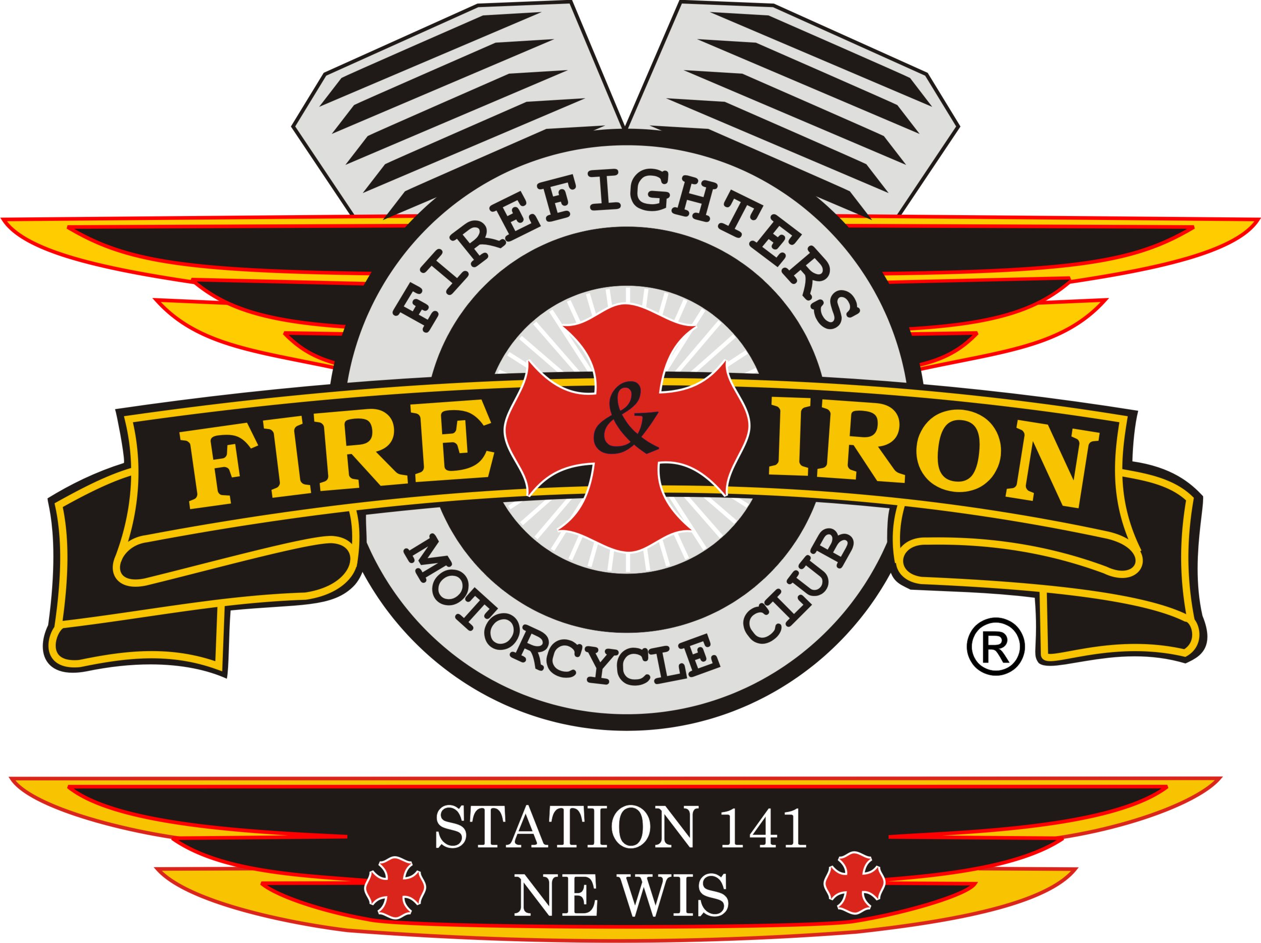

Fire and Iron M.C. Station 141

Meeting Agenda

Tuesday, July 15th, 2014

- Call to order By President John Lawler at 7:00 pm at Hobart Fire Dept
- Attendance: John L, Keith W, Tassie W, Roxanne L,Tim A, Jason D, Luke, James, Whitey 2
- Secretary’s report
- Approval of minutes from last meeting-Jason made motion to accept secretary’s report and Luke 2nd Motion carried
Note: There were 2 corrections to the minutes:
Item1: Jim Kasik has not joined as I had put in the minutes.
Item2: There were 2 people opposed to forming a Charity Committee versus 1 that I had in the minutes. Both items corrected.

- Upcoming and past events
Past
- Fire on the Fox: please get any suggestions that you may have that will improve Fire on the Fox night to Ozzy. We made $1624.43 in tips-WAY TO GO!!! Can cooler sales: $625.00, shirts $345.00. A great night but very hard work.
- Station 37’s Ride-Nick and Torch attended this but were not at the meeting to report.
- Michael Edwards Ride with Rolling Thunder-10 from the club attended-nice ride.
- Vet’s Ride-Tim A, attended-helped with blocking. 721 bikes and 121 cars. The ride went to Mishicot. Tim said that there were people all along the ride and some had chairs and love seats at intersections waiting for the ride to come thru
- Station 17’s Burn Camp Ride-John and Roxanne went down on Friday for the meet and greet. Keith, Nick and Tassie went down on Saturday morning for the ride. Very nice ride. No one got to wet-we stayed just ahead of the rain.

Upcoming:

- July 26th: Car wash at Kroll’s Bar in Sobieski-Tim A and his fiancé Kim L have decided to donate the money from this to the Burn Camp. So if you can’t wash cars then take your car there to be washed. 8am-4pm
- August 2nd-Station 77-Southern Illinois Ride
- August 3rd: Ride for Ryan Szpredja –JR’s on Velp-9-11 registration. Going to Two Rivers, Harp’s Lake. Band, Booyah etc
- August 8th- Oshkosh-Veteran Benefit Dinner $25 per ticket. For more details contact me-I will post it on Facebook
- August 10th Take kids to Burn Camp-Roxanne and Torch
- August 16th: Station 56 ride-John and Roxanne are attending

- August 14th-Burn Camp Media Day: John, Rox,Tim and Kim. 7am-2hr drive, 10am Parade-meet at Kwik Trip on 172 at 6:45am-call John with ????
- August 16th-Pick up kids from Burn Camp-Need 2 people, bus leaves at 6 or 7, goes to Milwaukee where most of the kids are dropped off then on to GB.
- August 23rd-Nicole Frye Ride-Rolling Thunder
- Treasurer’s report- Roxanne
We had been using year to date numbers versus month to month which is what we really are interested in. This will be corrected for next month’s report.
- VP report: Keith – Keith talked about the shooting with the Piston’s and the Iron Order. He called Kidd from the Piston’s and expressed our condolences on the lose of their brother.
Asked when the next meeting would be taking place with all the clubs in the area- Kidd will get back to him after everything settles down with the lose of their brother.
Nights of Inferno started a new chapter. The closest chapter is in Chicago.
- Sergeant at Arms report-none. Will talk about return of Kewaunee colors at next meeting
- Ride to Remember:
- Super 8 will be the hotel for this year’s ride on Mason and I43
- We received a football from the Packer’s Organization for our raffle
- New business:
Burn Camp Donation: this year it will be $17,817.00 (remember it is really from last year’s ride) John made a motion to give this amount to the Burn Camp, Tim A 2nd, motion carried. Last year we gave $12,749.00.

- Old business
Charity Committee-Jason, James and Tim A volunteered to be the committee.

- Next meeting location: Tentatively Pulaski (Whitey2)-August 19th 7pm. If this doesn’t work then Seymour could host
Monthly Ride: July27th-Station ride to Peshtigo-10am breakfast at Gilligan’s on Velp Ave.
Any interest in going on an overnight fall color run????
- Adjournment at 8:05 pm Tim A made motion to adjourn, Luke 2nd

